eMammal Implementation Essentials
Click on the boxes below to access parts of curriculum.
Accessing Data -
Online Resources for Curriculum Design
(Request via email from Dr. Stephanie Schuttler)
Setting the Traps and Collecting the Data – Selecting a Location and Methodology Video & Lessons

Make a Prediction – Brainstorm Species Richness

Camera Trapping & Science – Read about effective use of camera trapping as a scientific tool
The eMammal Process –
Overview
(Teacher Resource)
Introduction to Camera Trapping and Citizen Science -
Interactive Video

Student Engagement – A Family of Foxes Video

Curriculum Development

Arts & Humanities Language Arts Mathematics Social Studies Science Technology
eMammal Citizen Science Project data can be used to create relevant curriculum in any field of study at any grade level.
The possibilities are endless!

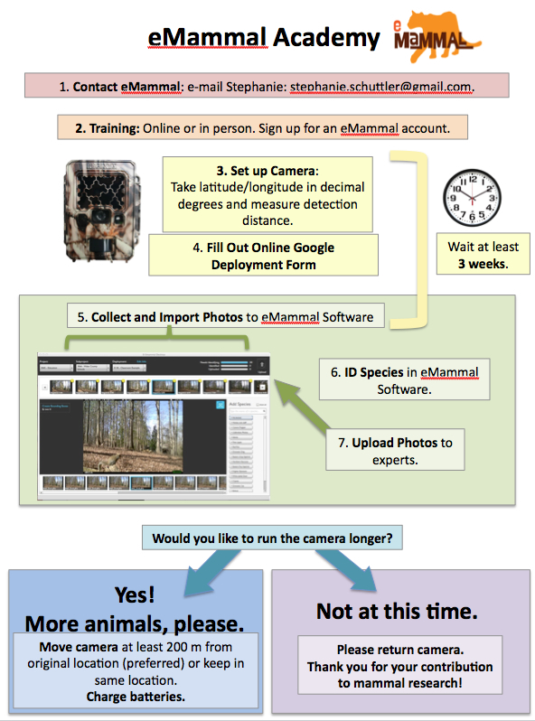

Camera Trapping and Science
by Dr. Stephanie Schuttler

Some of the fundamental questions of ecology include how organisms are distributed in time and space and how species interact with each other. Why are there so many species in one area and not another? Why are species increasing or decreasing over time at a single location? Answering these questions involves collecting data on species location and abundance. Mammals are especially interesting to ecologists because many can move large distances, are intelligent, have social interactions, can learn, and are often keystone species. They are also important to people for economic reasons, wildlife viewing, hunting and fascination.

Unfortunately for scientists, most mammals are secretive, and many are nocturnal, which makes them difficult to study. Two technological advances have helped scientists overcome these obstacles:
- radio and GPS collars that let researchers accurately track and locate individual animals, and
- camera traps, which are motion-and-heat-triggered cameras that capture photos of animals that move in front of the camera.
Researchers around the world now use camera traps to study mammals and other wildlife. Before cameras were used, survey methods included recording tracks and other animal signs, but these surveys required a high degree of expertise and signs were often missed or misinterpreted. Populations of secretive or low-density mammals, like threatened species and most carnivores, were underestimated or often undetected. Camera traps were developed to solve some of these problems, but the first cameras were heavy, sensitive to damage and limited by the constraints of film. Now camera traps can run for 6+ months off of 12 AA batteries, take thousands of digital photographs, and even record high-definition video. It is now possible to identify all terrestrial mammal species larger than 100 grams (about the size of a chipmunk) present in an area, record behavior and interactions, and—for animals that can be identified individually (such as striped or spotted animals)—estimate population size.

Scientists can use camera-trap surveys to gather baseline data about an area or answer specific questions. Baseline data are usually collected for long periods to monitor changes through time. For camera traps, they typically address what mammal species are present and the types of habitat they live in. Baseline data are especially important for conservation questions, such as how human development affects mammal species or how climate change affects mammals.
Examples of the types of questions you can investigate with camera trap data:
- Which habitat type has the most mammal species?
- How are mammals affected by road density?
- What mammals live in suburban areas? How does this compare to rural or wild areas?
- What kinds of habitat are associated with multiple detections of coyotes?

Once a question or hypothesis is generated, the cameras are placed across the study area to maximize data-collection to answer the research question. For example, to answer Question 4, we could count the number of coyote detections across different kinds of habitats for a certain period of time. Therefore, we would find different habitat types and place cameras in those habitats. Scientists usually have at least 20 camera locations (but around 50 is better) per area of interest to generate enough data to be able to compare habitats. In the case of camera traps, the pictures are the data. When an animal triggers the camera trap, the camera takes a series of photos (eMammal uses five or 10 “bursts” of photos). Through eMammal software, these bursts are separated into sequences, and animals that are separated by more than one minute apart are inferred to be different individuals. The software counts the number of animals for each sequence. One animal in one sequence is a distinct detection. For example, if there are two coyotes in one sequence, it counts as two coyote detections. You would add up and compare all of these detections for each habitat. The habitat with the most coyote detections might be inferred to be the one coyotes prefer. This could lead to more questions by students: Why is this? Is there more prey in this habitat? Fewer humans? Fewer predators? A key to science is answering questions that lead to asking more questions.

Below are some of the ways to quantify camera trap data for analysis:
- Activity pattern: Accumulation of detections for each hour and plotting; allows you to see what time of the day the animal is active (See Example)
- Diversity index: the number of species and the composition of the species within the community
- Occupancy: the probability of a certain species occurring at a site (requires sophisticated analysis; not feasible for the classroom)
- Relative abundance: the number of detections divided by the number of days the camera trap was in the field
- Species richness: the number of species at a site (See Instructions)

Make a Prediction (Teacher Instructions)
by Dr. Stephanie Schuttler
Have students complete the table on Page 6 (eMammal Predictions vs. Observations) before viewing camera trap photos.
Day 1
- Have students individually predict what mammal species they will find on the camera traps and list them in the first column of the table.
  - Students may think of non-mammals (e.g., reptiles, amphibians, birds). Explain that camera traps may capture birds, but this project focuses on mammals. Because birds can fly above camera traps, camera traps are not the best option for studying birds (observations through binoculars and listening to songs are the most common methods).
  - Students may think of small mammals (e.g., mice, moles, bats). Explain that these are an important part of the mammal community, but camera traps do not often capture images of these animals because they are small and live largely underground or fly (bats). Limit predictions to species larger than a chipmunk.
- Have students meet in small groups to compare their lists, adding species to their lists that other students have not thought of.
- As a class, fill in the table. Ask for a species from each group until there are no unique species to add. Ideally, you should post the sheet at a place in the classroom where all students can see it. Leave it in view for as long as the camera traps are operating.
- Have students count the number of animals in their predicted list. They are to write this number in the space in the Predicted Species Richness row.
- Explain that animals have activity patterns. For example, humans are diurnal—they are active during the day and sleep at night. Define the following words for students:
  - Nocturnal: active at night
  - Diurnal: active during daylight hours
  - Crepuscular: active at dawn and dusk
  - Ultradian: active throughout a 24-hour period
- Leave the columns Present, Detection Date and # of Days blank.
- For each species listed, have students predict whether they think the animal will be diurnal, nocturnal, crepuscular or ultradian. Have students choose one option for each species and place a “P” in the space (Activity Pattern columns) they think will best represent the predicted activity pattern for that species. The activity pattern fields should be updated with an “A” based on research and/or multiple observations.
Day ____
- During eMammal uploads, whenever a new species is identified, if it has been predicted by the class, put a “1” beside the species in the Present column. If it was not predicted, add it to the list and put a “1” in the Present column. Write new species that were not predicted in a different color, or draw a line separating the rows between new species additions from ones that were predicted—this way, students will know which ones are their predictions and which ones are additions.
- Enter the date on which the species was first detected (found on camera trap image).
Day _____ (Extensions)
- After all photos are collected, conduct Species Richness and Activity Patterns worksheets
(page 8).
- This would be a good time to update the Activity Patterns fields, if not already determined.

Name ________________________ Date ____________
eMammal Predictions vs. Observations
Location:______________________________________________________

Species Prediction  (List of Mammals) | Present (1)  Absent (0) | Detection Date | # of Camera Days | Activity Pattern
 |  |  |  | Diurnal | Nocturnal | Crepuscular | Ultradian
Predicted Species Richness
Actual Species Richness

Species Richness
Teacher Resource
By Dr. Stephanie Schuttler

Species richness is the number of different species that inhabit a given area. How the area is defined will change the number of species that are present, and usually bigger areas have more species. This is especially true when comparing the same habitat type (a small desert versus a big desert), whereas, in different habitat types, a small area may have many more species. For example, a small rainforest will have more species than a large desert.

Camera traps collect data only on mammals, and only mammals larger than 100 grams. In the eastern United States, these are animals larger than an eastern chipmunk (Tamias striatus). Bats, however, are excluded. Small mammals and bats account for most of the diversity within the class of mammals, so species richness calculated by camera traps represents only a subset of mammal diversity.

Often ecologists attempt to estimate species richness in very large areas. There are probability-based species-richness estimators that calculate a range of species-richness values based on how many species are captured in different sub-areas. Those methods require complicated statistics, so only the basic known species richness is presented here. Often ecologists may start with a list of expected species from past research or local knowledge.

Species Richness and Activity Patterns
Student Worksheet

- Look at your eMammal Predictions vs. Observations table. What species did you predict correctly? List and count them here:

- What species did you detect that you were not expecting to see? List and count them here:

- Transfer the following information from your Predictions vs. Observations table.

Location: _______________________________________________
Predicted Species Richness_________________________________

- Sum all the numbers in the Present column. Enter your total in the space next to Actual Species Richness and also in the space below:

Actual Species Richness:___________________________________

- Compare your Actual Species Richness value to your Predicted Species Richness value. Which is higher?

- What do you think it means to have high species richness?

- Which is better—higher species richness or lower species richness? Why?

- Below are pairs of ecosystems. Circle which of the two you think will have a higher species richness when including all animal species.

  - Coral Reef or Swamp

  - Tundra or Rainforest

  - Cave or Pine forest

