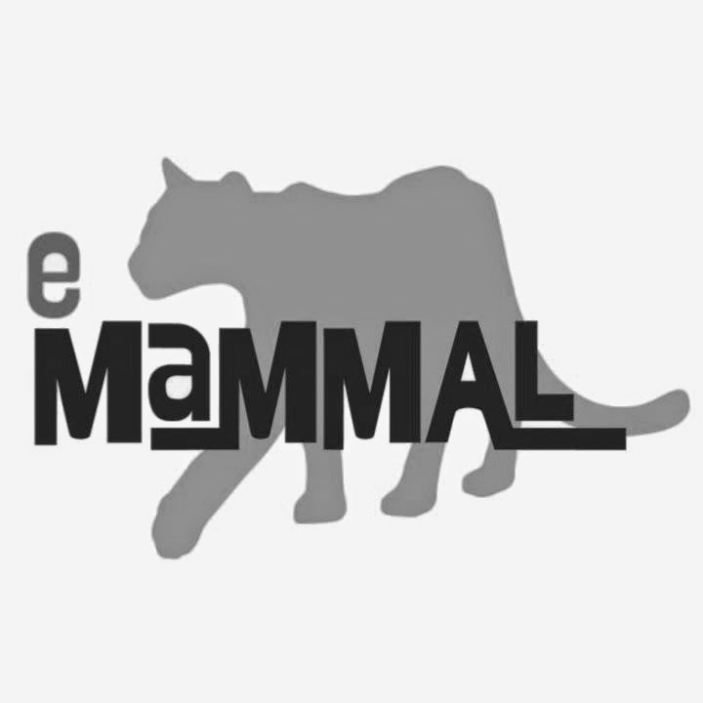
TEACHER ANSWER KEY

Guided Notes for Camera Trap Deployment Videos

For use with video: https://youtu.be/dRDyMm5eJe4

- The curved piece on the front of the camera is both
a heat sensor and a motion sensor.

- How many pictures will the Bushnell camera take? 3 Reconyx? 10

- The type of flash on a wildlife camera is an infrared flash.

- If the lens is obscured by dirt or smudges, you will not obtain good-quality images.

- True or False: All wildlife cameras use the same kind of batteries.

- When the Reconyx camera turns on, it gives information on what two parts of the camera?
Memory card storage and battery percentage

- What does the walk test help determine? Detection distance

- When you are ready to start capturing images, what should you do with the camera? Arm camera.

For use with video: https://youtu.be/KlZmfgNRqhI

- At what height should you deploy the camera? Knee height

- Plants/vegetation in front of the camera should be cleared.

- What are three things to avoid in setting up the camera? Small trees, stumps, trees that are leaning

- Use a zigzag pattern to walk in front of the camera during the walk test.

- What unit of measurement should be used to record detection distance? Meters

- Why wouldn’t you use a Python lock for a Bushnell camera? The cable doesn’t fit through the camera.

