Data Analysis Sheet
Ratios and Proportions with eMammal Data
NO CALCULATORS
Name: _____________________________ Date: _____________

In your own words:
- What is a ratio and how might one be used in science? _____________________________________
__________________________________________________________________________________
- What is a unit rate and how might one be used in science? __________________________________
__________________________________________________________________________________
- What is a proportion and how might one be used in science? ________________________________
__________________________________________________________________________________

- Select a mammal from a data sheet relating to one camera and calculate the Rate of Detections for one deployment (see labels on rates below). Set up a proportion to ESTIMATE how many times the mammal would be captured on the camera after 150 days, 300 days and 600 days based on one deployment. RECALCULATE your estimate based on 3 deployments.

ANIMAL:_________________________

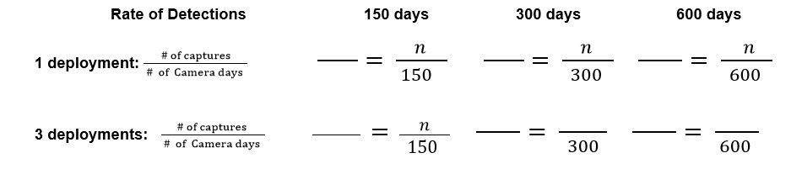
Which estimate do you think will be closer to the actual number? Why?
_____________________________________________________________________________________
_____________________________________________________________________________________
- Using the same mammal and information from the combined data sheet, calculate the Rate of Detections for one date range. Set up a proportion to ESTIMATE how many times the mammal would be captured on the camera after 150 days, 300 days and 600 days based on one deployment. RECALCULATE your estimate based on 3 date ranges.

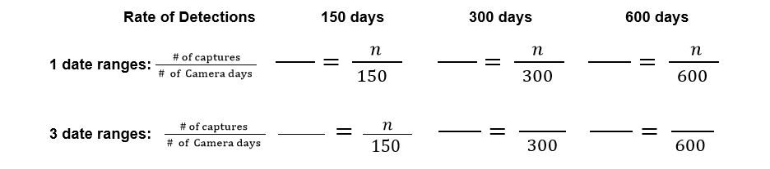
Which estimate do you think will be closer to the actual number? Why?
_____________________________________________________________________________________
_____________________________________________________________________________________
- How are the projections in problems 4 and 5 similar? How are they different? Do you think one strategy is better than the other? Why or why not?
_____________________________________________________________________________________
_____________________________________________________________________________________
_____________________________________________________________________________________
_____________________________________________________________________________________
- On a separate sheet of graph paper, create a line graph showing (camera days, cumulative captures) for the animal you are studying. Determine whether there is a proportional relationship and explain how you know.
_____________________________________________________________________________________
_____________________________________________________________________________________
- Compare your data with the data of two other students who used different animals. DISCUSS the similarities and differences, and then WRITE your observations here.
_____________________________________________________________________________________
_____________________________________________________________________________________
_____________________________________________________________________________________
- What level of confidence would you place on your estimates? Circle one:
No Confidence Somewhat Confident Very Confident
1 2 3 4 5
Explain your choice: ____________________________________________________________________
_____________________________________________________________________________________
Be sure to keep this documentation to compare with our actual camera trap results.

