Data Analysis Sheet — Teacher Key
Ratios and Proportions with eMammal Data
Name: __________________________ Date: _____________
TEACHER NOTE: Review explanations carefully and address any misconceptions individually, in small groups or as a class.

- What is a ratio and how might one be used in science?
Ratio: a comparison of two quantities
Uses in science: Responses will vary. Examples:
  - Density = mass/volume
  - % comparisons in any context are part to whole comparisons
  - Speed/distance = time
  - Comparisons between metric and English measurements
- What is a unit rate and how might one be used in science?
Unit Rate: a ratio of two different units with a denominator = 1
Uses in science: Responses will vary. Examples:
  - Measuring results of plant growth in cm per week
  - The speed of a slug in mm per minute
- What is a proportion and how might one be used in science?
Proportion: An equation written as two equivalent ratios
Uses in science: Responses will vary. Examples:
  - If we know a shark’s length is in direct proportion to the size of its teeth, we can estimate the size of a shark using teeth we find on the beach. (See Shark Teeth Forensics lessons http://studentsdiscover.org/teaching-modules/shark-teeth-forensics/.)
  - Proportions are used to estimate distance of planets from Earth.
The Merriam-Webster Dictionary offers these definitions:
Ratio: the relationship that exists between the size, number or amount of two (or more) things, which labels can help us understand
Rate: a special ratio that compares two quantities of different units-of-measure
Unit rate: a special rate in which the second term is 1. Words to describe unit rates include “per” and “each”.
Proportion: two equivalent ratios. When 3 of 4 quantities are known in a proportional relationship, the fourth can be determined through various mathematical calculations.
- Select a mammal from a data sheet relating to one camera and calculate the Rate of Detections for one deployment (see labels on rates, next page). Set up a proportion to ESTIMATE how many times the mammal would be captured on the camera after 150 days, 300 days and 600 days based on one deployment. RECALCULATE your estimate based on 3 deployments.

The following sample data is taken from the Valley Springs Middle School eMammal project (ValleySpringsData.xlsx).

ANIMAL:__N. RACCOON ____(NRC185)___

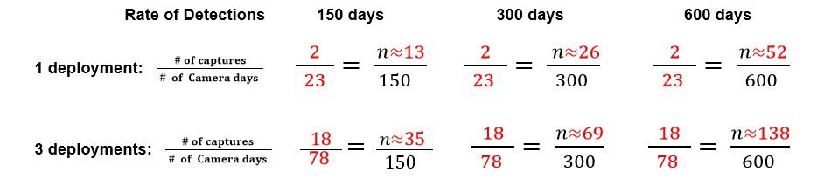
Which estimate do you think will be closer to the actual number? Why?
Talking points: More data = better estimate. Longer projections may be affected by outside factors like seasons, vacations, etc.
Tabs on .xls file NRC185 and NRC29 have 156 camera days each; NRC187 and NRC211 have 127 camera days, so students can compare calculation to actual data. You could even have students change the estimate to 130 if students use data from the two cameras with 127 days.
Facts to consider: Each camera for this data set was kept in the same location.

- Using the same mammal and information from the combined data sheet, calculate the Rate of Detections for one date range. Set up a proportion to ESTIMATE how many times the mammal would be captured on the camera after 150 days, 300 days and 600 days based on one deployment. RECALCULATE your estimate based on three date ranges.

The following sample data is taken from the Valley Springs Middle School eMammal project (ValleySpringsData.xlsx).

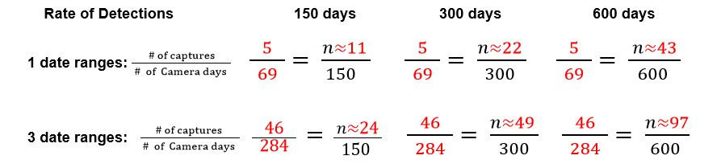
(7/19 – 8/10; 8/10 – 9/6 (split dataset); 9/6 – 10/2)
Which estimate do you think will be closer to the actual number? Why?
Talking points: More data = better estimate. Longer projections may be affected by outside factors like seasons, vacations, etc.
Combined data set is 596 camera days. Total # of N. Raccoon captures = 129; Why might the camera data projection be closer to the actual count? If raccoons are mostly captured on that camera, the other data would skew projection from other cameras.
- How are the projections in problems 4 and 5 similar? How are they different? Do you think one strategy is better than the other? Why or why not?
Talking points: The questions are meant to get students to think and be able to defend an answer.
- On a separate sheet of graph paper, create a line graph showing (camera days, cumulative captures) for the animal you are studying. Determine whether there is a proportional relationship and explain how you know.
Talking points: Even though data will not likely be proportional [linear and passing through (0,0)], discuss the trend line and determine whether or not students can still make a “reasonable” estimate.
- Compare your data with the data of two other students who used different animals. Discuss the similarities and differences, and then write your observations here.
This summarizing activity will allow students to find their own problems and misconceptions and should provide good feedback. Listening to discussions and having students share conclusions can enable you to informally assess the students’ level of understanding.
- What level of confidence would you place on your estimates? Circle one: Responses will vary.
No Confidence Somewhat Confident Very Confident
1 2 3 4 5
Explain your choice: ____________________________________________________________________
_____________________________________________________________________________________
Be sure to keep this documentation to compare with our actual camera trap results.

